Various Times Related To Process-

Various times related to process are-

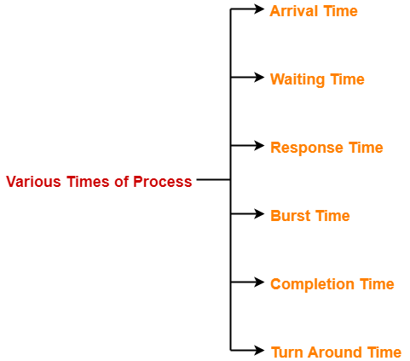

- Arrival time
- Waiting time
- Response time
- Burst time
- Completion time
- Turn Around Time

1. Arrival Time-

- Arrival time is the point of time at which a process enters the ready queue.

2. Waiting Time-

- Waiting time is the amount of time spent by a process waiting in the ready queue for getting the CPU.

Waiting time = Turn Around time – Burst time

3. Response Time-

- Response time is the amount of time after which a process gets the CPU for the first time after entering the ready queue.

Response Time = Time at which process first gets the CPU – Arrival time

4. Burst Time-

- Burst time is the amount of time required by a process for executing on CPU.
- It is also called as execution time or running time.
- Burst time of a process can not be known in advance before executing the process.
- It can be known only after the process has executed.

5. Completion Time-

- Completion time is the point of time at which a process completes its execution on the CPU and takes exit from the system.
- It is also called as exit time.

6. Turn Around Time-

- Turn Around time is the total amount of time spent by a process in the system.
- When present in the system, a process is either waiting in the ready queue for getting the CPU or it is executing on the CPU.

Turn Around time = Burst time + Waiting time
OR
Turn Around time = Completion time – Arrival time

Important Note-

While discussing the above definitions,
- We have considered that the process does not require an I/O operation.
- When process is present in the system, it will be either waiting for the CPU in the ready state or it will be executing on the CPU.

